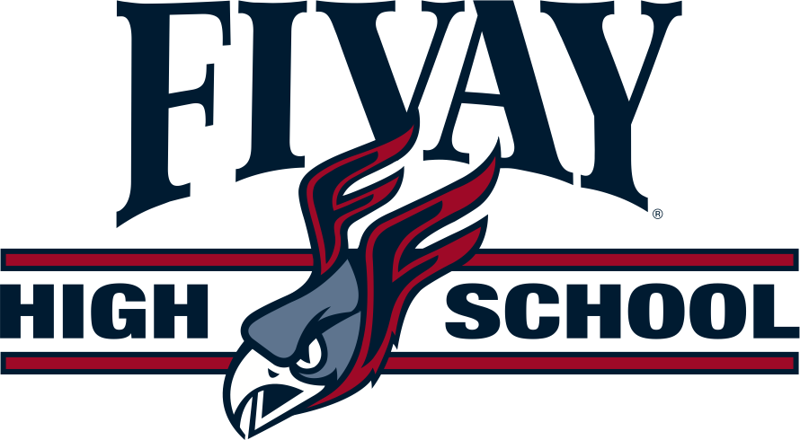

***Home of the Falcons***

*12115 Chicago Avenue • Hudson, FL 34669 • (727) 246-4000 • (727) 246-4091 Fax*

***Erik Hermansen****, Principal*

***Mark Feldman,*** *Asst. Principal**•* ***Robert Burgos,*** *Asst. Principal*

***Jennifer Greco-Ball,*** *Asst. Principal •* ***Heather Bell,*** *Asst. Principal*

July 15, 2024

Dear Parent/Guardian,

Welcome to the 2024-2025 school year. We are excited to partner with you to make this year's students the best yet! As you may know, our school is a Title I school, and as such, we receive federal funding to supplement the school's existing programs to help all students succeed and succeed.

As a Title I school, we also know the value of working with you as a parent/guardian. Attached to this letter is a copy of our parent involvement plan. This plan communicates our commitment to partnering with families and outlines how we intend to work with families this year. You can also find copies of this plan and the district-wide plan on our website (put your website here). These plans, the School Success Plan and the Comprehensive Needs Assessment, are also available at the school. If you want to see them, ask the front desk staff to see the family/community folder.

Also attached to this letter is our school-family pact. This compact is an agreement between the school, parents, and students for everyone to do their part to make sure each child reaches their full academic potential. Please sign this covenant and send it back to school.

As a parent of a student at a Title I school, you also have some specific rights that we would like to inform you of. You have the right to know the professional qualifications of the educators who instruct your child. Federal law allows you to get certain information in a timely manner about your child's classroom teachers and instruction/paraprofessional assistants. You have the right to request the following information about each of our children's teachers and instructional/paraprofessional assistants:

1. The teacher's Florida certification area(s) and, whether the teacher is teaching in the field, or whether the teacher is qualified in the field according to Pasco County Schools.
2. The teacher's university degree(s) and areas of study.
3. The master's advanced university degrees and areas of study.
4. The qualifications of any instructional assistants/paraprofessionals who provide services to your child.

In addition, you have the right to be provided with information about your student's level of achievement on assessments such as BEST in reading/language arts, FAST in math, and science EOC. This information will be available at your child's school.

If you would like to receive any of this information, please send a written request to your child's school. To learn more about what it means to be a Title I school and ways we can work together to support your child, join us at the Title I Annual Meeting, August 21, 2024 at 6:30 pm in the cafeteria.

Thank you

Erik Hermansen

Principal, Fivay High School

District School Board of Pasco County

District Wide Accreditation - Southern Association of Colleges and Schools

Council on Accreditation and School Improvement (SACS CASI)

Kurt Browning, Superintendent