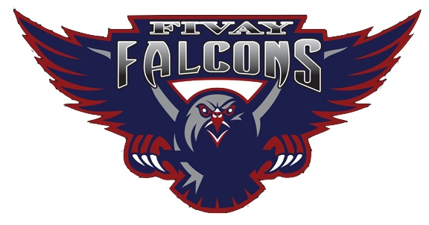**Fivay High School - Home and School Compact Form**

Student Name: ___________________________________ School Year ____________

Parent Email Address ______________________________________________________

Parent Telephone number _________________________________________________

**Fivay High School Family Involvement Plan:** We believe in the importance of a partnership between parents/caregivers and school staff for the education of your child (our students). We will maintain open communication with social media (FHS Website, Facebook, FHS X), School Messenger Telephone calls, myStudent Communication, and email accounts. Parents/Caregivers are encouraged to open their own myParent Portal to continuously monitor their child’s academic progress and attendance/tardies. We will attempt to communicate in a parent’s/caregiver’s home language. Parents and other family members are encouraged to participate through student recognition and extra-curricular events. Parents are also welcome to become registered volunteers, then volunteer at the school to assist teachers with secretarial tasks or by mentoring a student. By working together, we will make a difference in the lives of our students. This compact is an agreement designed to promote a partnership between the home (parents/caregivers) and the school, which meets the requirement of the Title 1 Federal Guide.

**What is our Purpose? FHS Vision**

* All FHS students will be Life, Career, and College ready

**What do you hope to accomplish? Student Outcomes/Expectations. The student will:**

* Obtain a High School diploma with age-appropriate peers
* Consistently self-regulate behavior in both individual and group settings according to our FHS Shared Values without adult assistance

**As a family, we will:**

1. Ensure daily attendance for the entire instructional day (8:10a.m.- 2:35p.m.).
2. Support and expect positive behaviors by my child, which supports the FHS Vision, Student Outcomes/Expectations, and Shared Values.
3. Take a positive active role in my child’s success by registering for a myParent portal, monitoring my child’s progress using myParent portal, plus providing a current telephone number to receive School Messenger (Telephone) calls.
4. Schedule an appointment with appropriate staff for problem-solving concerns.

Take an active role in parent involvement activities. FHS Website (<https://fhs.pasco.k12.fl.us/>), FHS Facebook <https://www.facebook.com/FivayHS/?ref=bookmarks>

1. Take a positive active role in the success of FHS. Register as an approved volunteer.

**(Please see back)**

**Fivay High School - Home and School Compact Form (pg. 2)**

**As a student I will consistently demonstrate (and model for other students) our FHS Shared Values as I:**

1. Obtain a High School diploma with age-appropriate peers
2. Consistently self-regulate behavior in both individual and group settings according to our FHS Shared Values without adult support.
3. Own my behaviors
4. I will monitor my levels of being “On Track” with FHS student outcomes/expectations and I will participate in:
   1. Recognition activities that celebrate desired behaviors that support the FHS vision.
   2. Demonstrate desired replacement behaviors that move me from “Off Track and At Risk,” to “On Track” recognition/status to participate in incentives.

**As the Falcon Fivay Staff we will:**

1. Connect and partner with parents/caregivers with supporting each child in being life, career, and college ready.
2. Demonstrate compassion and seek to better understand our students to provide excellent academic and social emotional learning.
3. Create an emotionally and physically safe and secure school.
4. Consistently model and promote the FHS Shared Values.
5. Ensure delivery of a guaranteed and viable curriculum that ensures the success of all learners.
6. Communicate regularly through MyStudent and Social media accounts.
7. Develop and foster relationships that create opportunities and connections to the community.

I have received a copy of the District School Board of Pasco County tri-fold

“**Parent Engagement Matters: A Guide to Title I**”

explaining the goals of Title I schools.

Parent/Guardian Signature ___________________________________________________ Date__________________________

Student Signature_____________________________________________________________ Date__________________________

School Designee Signature_______________________________________________________ Date__________________________

*“Partners in Education”*