Home of the Falcons | Jason Joens, Principal
12115 Chicago Avenue Hudson, FL 34669 | Travis De Walt, Assistant Principal
(727) 246-4000 Phone | Kristen Martanovic , Assistant Principal
(727) 246-4091 Fax | Kevin Smith, Assistant Principal
www.fhs.pasco.k12.fl.us | Deanna Waide, Assistant Principal
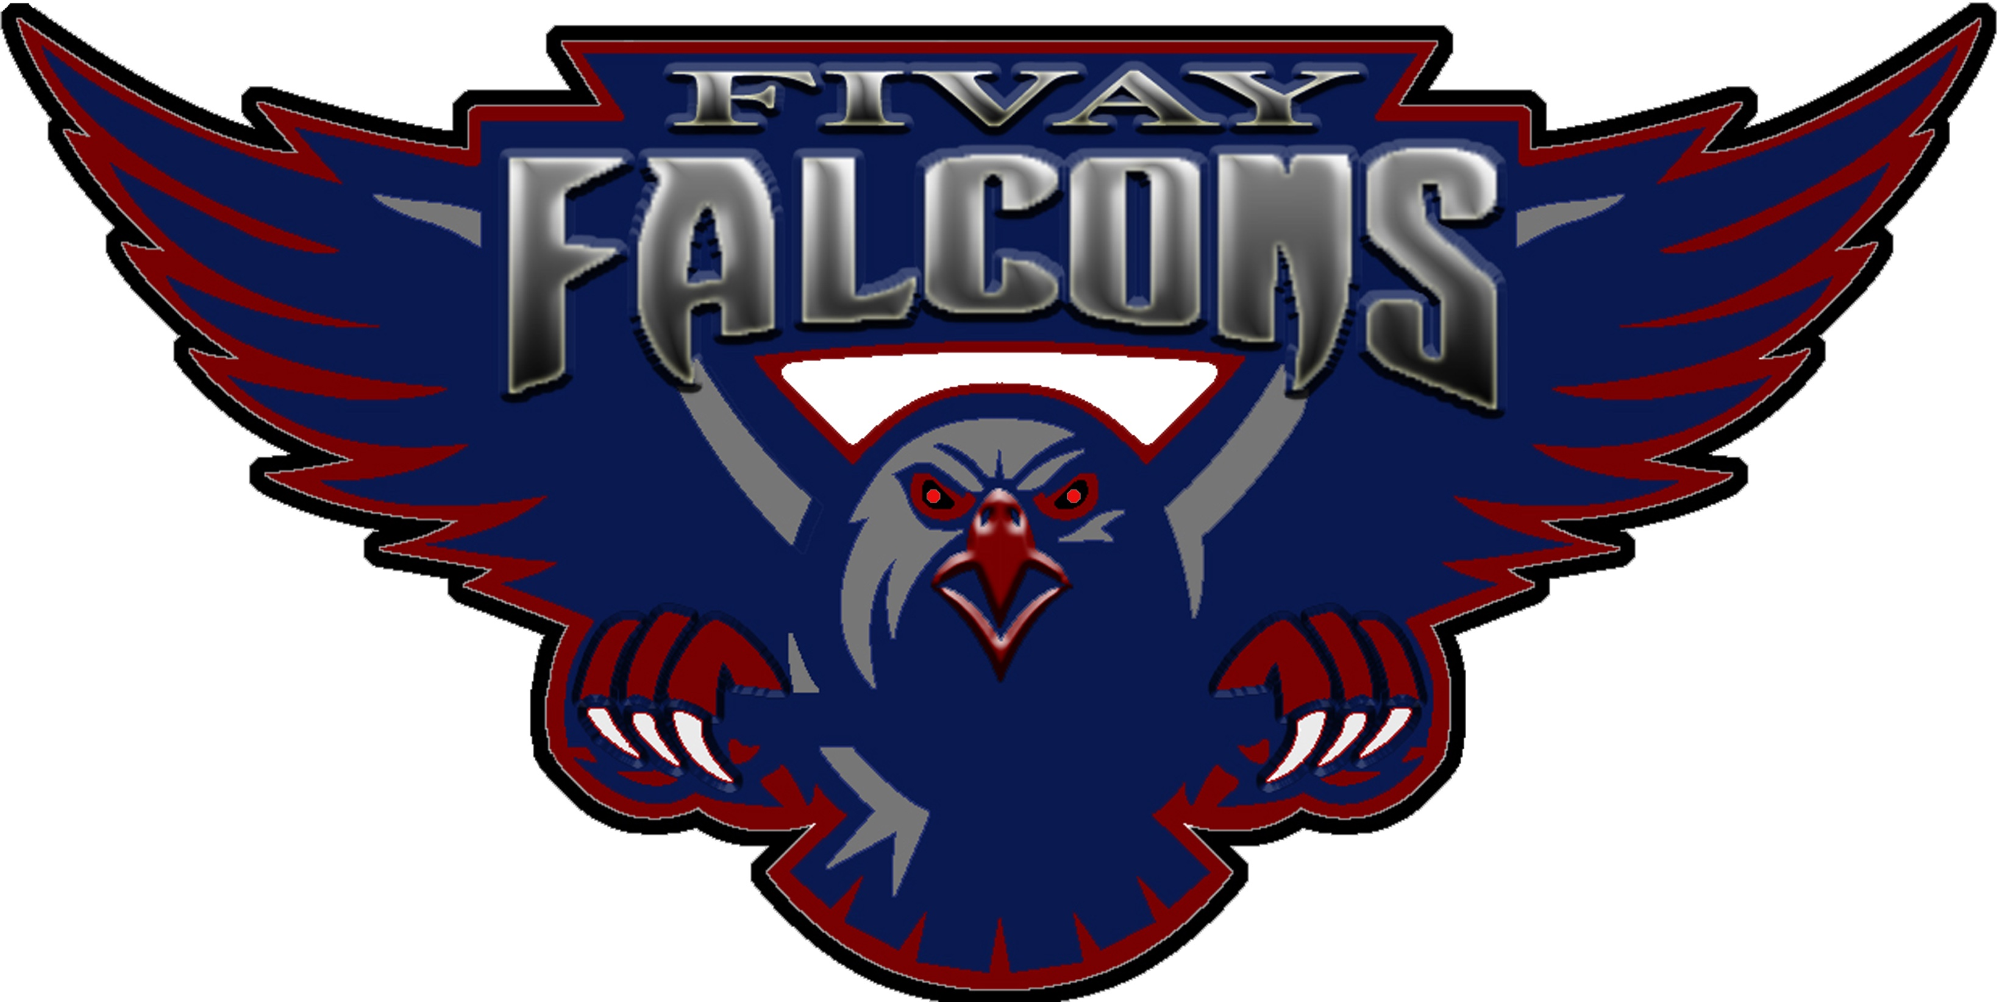

September 2020

Annual Title One meeting FHS
Parents Right to Know

Dear Parents or Caregivers,

You have the right to know the professional qualifications of the educators who instruct your child. Federal law allows you to obtain certain information in a timely manner about your child’s classroom teachers and instructional assistants/paraprofessionals. You have the right to ask for the following information about each of our child’s teachers and instructional assistants/paraprofessionals:

- The teacher’s Florida certification area(s) and, if the teacher is teaching infield, or if the teacher is
qualified infield according to the District School Board of Pasco County.
- The teacher’s college degree(s) and areas of study.
- The teacher’s advanced college degree(s) and areas of study.
- The qualifications of any instructional assistant/paraprofessionals who provide services to your child.

In addition, you have the right to be provided information on your child’s level of achievement on assessments like Florida Standards Assessment (FSA) in Reading, English Language Arts, Mathematics and Science. This information is available here at school.

If you would like to receive any of this information, please send a written request to our Student Services Team.

Sincerely,

Jason Joens
Principal

District School Board of Pasco County
District Wide Accreditation - Southern Association of Colleges and Schools
Council on Accreditation and School Improvement (SACS CASI)
Kurt Browning, Superintendent

