Home of the Falcons | Jason Joens, Principal
12115 Chicago Avenue Hudson, FL 34669 | Travis De Walt, Assistant Principal
(727) 246-4000 Phone | Jennifer Greco-Ball , Assistant Principal
(727) 246-4091 Fax | Kristen Martanovic , Assistant Principall
www.fhs.pasco.k12.fl.us | Kevin Smith, Assistant Principal
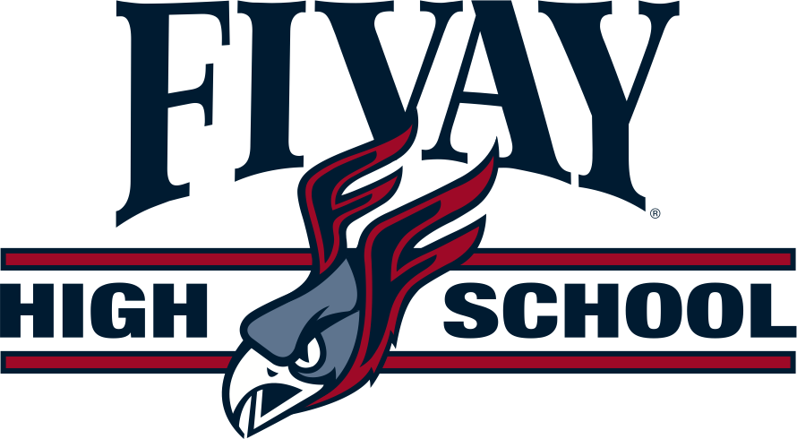

September 2020

Title One Annual Parent Letter

Dear Parent/Guardian,
Welcome to the 2020-2021 school year. We are excited to partner with you to make this year your students best one yet! As you may know, our school is a Title I school, and as such, we receive federal funding to supplement the school’s existing programs to help all students succeed and achieve.
As a Title I School we also know the value of working with you as a parent/guardian. Enclosed in this letter you will find a copy of our parent engagement plan. This plan serves to communicate our commitment to partnering with families and outlines how we intend to work with families this year. You can also find copies of this plan and the districtwide plan on our website www.pasco.k12.fl.us.com. These plans, the School Success Plan and the Comprehensive Needs Assessment, are also available at school. If you wish to see them, please ask the front office staff to see the family/community binder.
Also enclosed is in this letter is our school-family compact. This compact is an agreement between the school, parents and students to all do their part to make sure each child achieves to their highest academic potential. Please sign this compact and send it back to school.
As a parent of a student at a Title I school you also have some specific rights of which we would like to inform you. You have the right to know the professional qualifications of the educators who instruct your child. Federal law allows you to obtain certain information in a timely manner about your child’s classroom teachers and instructional assistants/paraprofessionals. You have the right to ask for the following information about each of our child’s teachers and instructional assistants/paraprofessionals:
- The teacher’s Florida certification area(s) and,if the teacher is teaching infield, or if the teacher is qualified infield according to Pasco County Schools.
- The teacher’s college degree(s) and areas of study.
- The teacher’s advanced college degree(s) and areas of study.
- The qualifications of any instructional assistant/paraprofessionals who provide services to your child.
In addition, you have the right to be provided information on your student’s level of achievement on assessments like FSA in reading/language arts. Mathematics and science. This information will be available at your child’s school.
If you would like to receive any of this information, please send a written request to your child’s school. To learn more about what it means to be a Title I school and ways we can work together to support your child, please join us at Open House and Annual Title I Meeting during semester one.

